Inspiring All to Excellence

Heathfields Infant & Wilnecote Junior Academy

Religious Education (R.E.) Policy

Document Control

Document Title | Religious Education (R.E.) Policy
Effective Date |  | 13th February 2022
Review Date | 13th February 2024
Policy Owner | Lauren Paskin
Policy Approver

Version Control

Version | Date | Amended by | Comments
1 | 13/2/22 | Lauren Paskin
2 | 06/11/22 | Lauren Paskin
3 | 09/12/22 | L Paskin and L Williams | Updated the KS2 curriculum and included the RE key skills and progression documents

Section | Changes Made
Appendices | Added progression documents and the new long term plan to appendices.

Rationale
Religious Education is unique in the school curriculum in that it is neither a core subject nor a foundation subject but the 1988 Education Act states that ‘Religious Education has equal standing in relation to core subjects of the National Curriculum in that it is compulsory for all registered pupils.

Religious Education is taught in our school because it makes:

“A major contribution to the education of children and young people. At its best, it is intellectually challenging and personally enriching. It helps young people develop beliefs and values, and promotes the virtues of respect and empathy, which are important in our diverse society. It fosters civilised debate and reasoned argument and helps pupils to understand the place of religion and belief in the modern world”. (RE: realising the potential, Ofsted 2013).

At the Heathfields Infant and Wilnecote Junior Academy we aim to provide a broad and balanced curriculum for all children.

We aim to welcome all children into a caring environment; where they can develop to their full potential and in which attitudes of mutual respect and responsibility are promoted.

We deliver RE in line with the Staffordshire Locally Agreed Syllabus. We use the Discovery RE programme as our scheme of work.

This RE policy is informed by current national guidance:
RE in English Schools: Non-statutory guidance (2010)
RE: realising the potential (Ofsted 2013)
A Curriculum Framework for RE in England, (REC 2013)
Research review series: religious education (2021)

British Values and UNICEF
This policy reflects contributions by the whole school community including learners, staff, parents, carers and governors as a Rights Respecting School and should therefore be promoted by all community members.

We take every opportunity to promote the fundamental British values of:
- Democracy
- The rule of law
- Individual liberty
- Mutual respect and tolerance of those with different faiths and beliefs
In actively promoting British Values, we also focus on and can show, how our work with students is effective in embedding fundamental British values. Actively promoting also means challenging students, staff, parents, or carers that may express opinions contrary to fundamental British Values, including extremist views.

Growth Mindset
A key concept which shapes the ethos of our school is growth mindsets based on the work of Carol Dweck. Rather than simply praising success we praise effort and persistence. Children are encouraged to approach all aspects of school life with a positive mentality and resilience, allowing them to achieve all that they are capable of. Our behavior policy falls in line with this approach as children are supported to regulate their emotions as they move through our ‘behavior islands’.

We have a three-tier behavior management system:
- When the children are showing a positive attitude towards their learning or play then they are on the pink island.
- If the child is not able to show a positive attitude towards their learning or play then they will be reminded and asked to regulate and change their behavior, if they are not able to do this they will move to the green island.
- If they manage their behavior through regulation they are praised and moved to the purple island to celebrate the change in attitude.

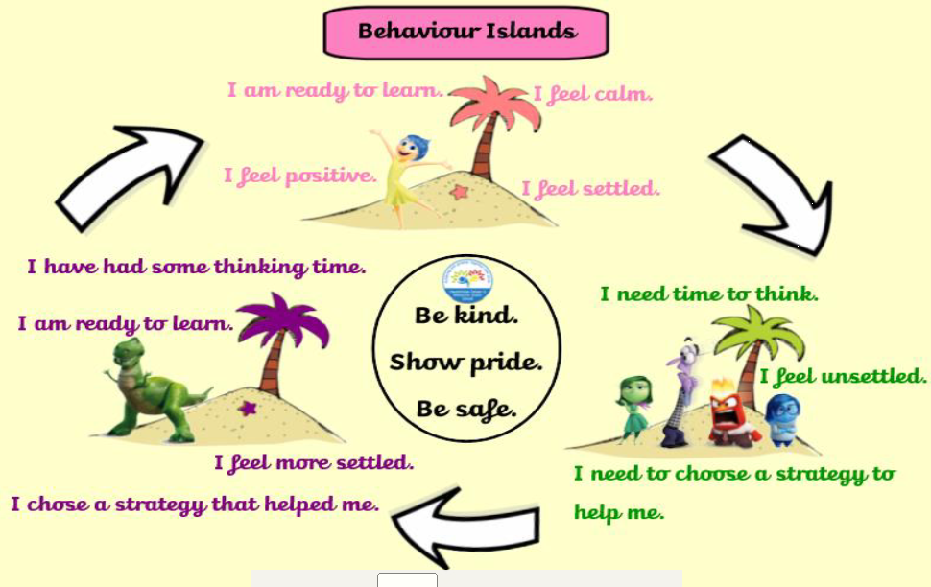
As with other behavior management systems, some behavior will be deemed as unacceptable.
All classes have a ‘regulation station’ which children can access freely to regulate their emotions when moving through the behaviour islands.

Aims
At Heathfields Infant and Wilnecote Junior Academy, we want our children to make sense of what they have learnt in RE and gain an understanding of different cultures and religions through shared experiences, reasoning, and reflection.
The aim of us RE teaching is to deepen children’s critical thinking skills through greater subject knowledge and to allow their own spiritual development. Our belief is that, using an enquiry-based model well, children’s critical thinking skills can be developed, their motivation to learn increased, and their knowledge and understanding of, and empathy with people and their beliefs, religious or otherwise, will be enhanced. This approach takes very seriously the philosophy that children are free to make their own choices and decisions concerning religion and belief. Through our RE programme our children:
Learn about religion by:
- gaining a secure knowledge and understanding of the beliefs and practices of Christianity
- beginning to explore other faiths and perspectives
Learn from religions by developing the ability to:
- express curiosity about fundamental questions of life
- understand and use religious language
- reflect on beliefs, practices, values, and traditions in order to understand their influence on the individual, on community life and on culture (including British Values and spiritual, moral, social and cultural aspects of life)
- understand that for some questions there are no right or wrong answers
- make informed responses to religious and moral issues
- identify the relationship between religious beliefs, human responsibility, global issues, and the natural world
In line with the Staffordshire Agreed Syllabus, through the provision of our RE curriculum, we want our children to acquire:
- An increasing core of insightful knowledge concerning religions and beliefs, by exploring religious beliefs, teachings, and practices
- A developing capacity to engage with ultimate questions and to formulate their own sense of identity and values; by engaging with fundamental questions
- A growing range of the social, spiritual, and emotional skills and dispositions appropriate to living well in a religiously plural and open society, through informed discussion and personal reflection
At Heathfields Infant and Wilnecote Junior Academy, we follow the Discovery RE program with adaptions to align our curriculum with the Staffordshire Agreed Syllabus (see Appendix 1 for the progression document). Each RE lesson will provide an opportunity to explore, build knowledge and understanding, and encourage children to reflect on the subject. This is done as the children explore the 3 key enquiry skills of R.E. ( See Appendix 2)
By the end of the unit, each child reflects on what they have learnt by assessing their own understand of key vocabulary and concepts and comparing this to their initial understanding to understand how they have progressed as an individual throughout each unit. (See Appendix 5)

Intent
According to the R.E. Council, ‘the ability to understand the faith or belief of individuals and communities and how these may shape their culture or behaviour, is an invaluable asset for children in modern day Britain.’ At Wilnecote Junior Academy, in line with Staffordshire County Council syllabus for Religious Education, R.E. lessons will provoke challenging questions about meaning and purpose in life and the beliefs of others.
Pupils will learn to express their insights and to agree or disagree respectfully. By the time a child leaves Wilnecote Junior Academy in KS2, they will be expected to:
- Develop deepening knowledge and understanding about a range of religious and non-religious world views.
- Describe and explain the beliefs of others.
- Describe and explain ways in which beliefs are expressed.
- Know and understand the significance and impact of beliefs and practises of individuals, communities, and societies.
- Connect these together and draw links between religions and with their own beliefs as an individual in an ever-changing society.
- Gain and deploy deepening understanding of specialist vocabulary and terms.
- Know and understand about religious diversity within the region, as well as nationally and globally.
- Gain and deploy skills that enable critical thinking and enquiry in relation to the material they study.
- Reflect on their own thoughts, feelings, experiences, ideas, values, and beliefs with increasing discernment.
We are committed to providing our children with an exciting and positive learning environment, with a wide range of opportunities to support their learning, in which they can develop their knowledge and understanding of religions while contributing to their spiritual, moral social and cultural development.

Implementation
- R.E. is well planned and resourced with clear structure to sustain pupils’ natural curiosity so that they are eager to learn and develop investigative skills.
- Opportunities for cross-curricular learning are considered and children are encouraged to use the vocabulary taught during R.E. lessons in other subjects and in real life situations.
- Children are given opportunities to reflect on prior learning through their knowledge organiser which is stuck in at the start of each academic year (see Appendix 3).
- Opportunities for assessment are carefully considered and implemented during R.E. lessons to address any misconceptions and support children’s understanding.
- R.E. is assessed through the children’s acquisition of key vocabulary each half-term, this is then retested at the end of the academic year to see what the children have retained. (see Appendix 5)
- R.E. is all-inclusive and diverse where any misconceptions are addressed to enhance R.E. concepts.
- Learning relates to real life experiences of the children so that they can apply their understanding to the real world.

Impact
In R.E., we strive to ensure that our children’s progress is in line with or exceeding their potential when we consider the varied starting points and different world views of our children. At Wilnecote, children in the past have been considered to have a very narrow world view and their perceptions of the world are heavily influenced by the surrounding environments. We measure the children’s starting points carefully using a range of materials, including, but not limited to, vocabulary banks to assess the children’s prior knowledge and then how the children’s knowledge progresses as the year goes on. We intend that the impact is that children will be prepared for life in their next school stage, in modern Britain and the wider world as we recognise the importance of this for young people to become a good citizen and be inclusive within their own society.

Organisation
At the Federation of Heathfields Infant and Wilnecote Junior Academy, RE lessons are taught once per week (See Appendix 3 for Long Term Plan). Some areas of learning are linked within other topics if appropriate.

Teaching strategies are varied and are mindful of preferred learning styles and the need for differentiation. Each enquiry starts from the children’s own life experiences using these as a bridge into the investigation of the religion being studied and build towards an expression of the children’s learning and development of understanding. Children have opportunity to express their own thoughts and beliefs and empathise with believers of that religion or belief position and are given opportunities to reflect on their learning and on key questions relating to each religion within their enquiry.

In KS2, the final unit in each year group allows children to draw together all of their knowledge about the religions taught in our school to compare and contrast practices and values at key points in a person’s life starting from the beginning right up until the end. (See Appendix 1) This also allows children to consider their own personal agendas alongside those of people with non-religious views on key events in a person’s life e.g. birth, coming of age, marriage and death.

Differentiation/SEN
Our RE curriculum is written as a universal core curriculum provision for all children. Inclusivity is part of its philosophy. Teachers will tailor each enquiry to meet the needs of the children in their classes. To support this differentiation, many enquiries suggest creative learning activities that allow children to choose the media with which they work and give them scope to work to their full potential.

Monitoring and evaluation
The Curriculum leader and R.E. leader monitors delivery of the programme through observation and discussion with staff whilst planning and delivering the lessons, as well as discussions with children and scrutiny of their written work to ensure consistent and coherent curriculum provision. At key stage 2, children also self-assess their learning for each unit using vocabulary assessment sheets. At the beginning of each new unit, children assess their understanding of key vocabulary and then revisit this at the end of the unit to see how much language they have acquired through the teaching and learning that has taken place during that half term (see Appendix 5).

Evaluation of the programme’s effectiveness is conducted based on:
• Pupil and teacher evaluation of the content and learning processes through conferencing and staff questionnaires.
• Staff meetings to review and share experience.
• Monitoring of assessment to ensure progression throughout the school.

External contributors
RE gives opportunities to promote an ethos of respect for others, to challenge stereotypes and build an understanding of other cultures and beliefs. This contributes to promoting a positive and inclusive school ethos that champions democratic values and human rights.
Heathfields Infant and Wilnecote Junior Academy has links with the local church and the community. We have regular visits from the church, teaching children bible stories and what lessons we can learn from them.
Each year, a visit to the Open Centre in Derby is arranged for Year 5 pupils so that children can take part in a Faith Trail, visiting different places of worship and learning more about their religious practises.

The Learning Environment
Establishing a safe, open, and positive learning environment based on trusting relationships between all members of the class, adults, and children alike, is vital. To enable this, it is important that respect for each other’s views and beliefs of those of the believers of that religion is always encouraged and that any artefacts are handled with respect and care.

Teaching Sensitive and Controversial Issues Involving parents and carers
Sensitive and controversial issues are certain to arise in learning from real-life experience and discussing personal beliefs.
Topics are presented using a variety of views and beliefs so that pupils can form their own, informed opinions but also respect that others have the right to different opinions. Teachers should never feel obliged to discuss their own beliefs unless they feel comfortable doing so and can ensure that this will not influence or restrict the children’s own expression.
Heathfields Infant and Wilnecote Junior Academy believes that it is important to have the support of parents, carers, and the wider community for the RE programme. Parents and carers are/will be given the opportunity to find out about and discuss RE through our open-door policy.

Withdrawal from RE lessons
Parents/carers have the right to withdraw their children from all or part of the Religious Education. Those parents/carers wishing to exercise this right are invited in to see the class teacher and head teacher who will explore any concerns and discuss any impact that withdrawal may have on the child. The school will ensure that parents who want to withdraw their children from RE are aware of the RE syllabus and that it is relevant to all pupils and respects their own personal beliefs. Parents will be made aware of the learning objectives and what is covered in the RE curriculum and should be given the opportunity to discuss this if they wish. The school may also wish to review such a request each year, in discussion with the parents.

The use of the right to withdraw should be at the instigation of parents and it should be made clear whether it is from the whole of the subject or specific parts of it. No reasons need be given. Where parents have requested that their child is withdrawn, their right must be respected, and where RE is integrated in the curriculum, the school will need to discuss the arrangements with the parents or carers to explore how the child’s withdrawal can be best accommodated. Once a child has been withdrawn, they cannot take part in the RE programme until the request for withdrawal has been removed.

As a school it is our duty to inform our local Standing Advisory Council on RE regarding the numbers of children being withdrawn.

Appendix 1
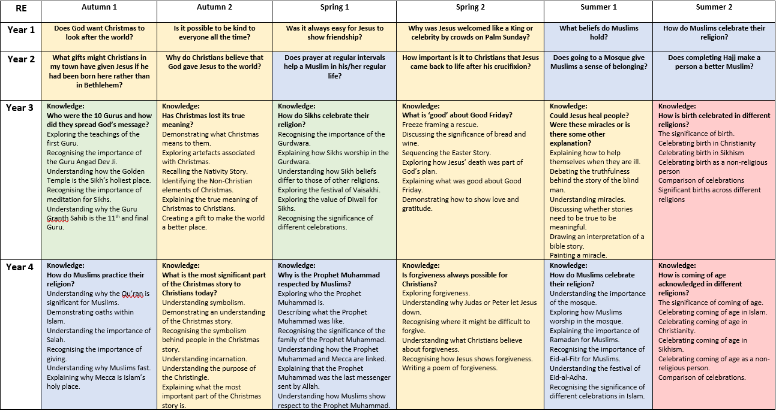

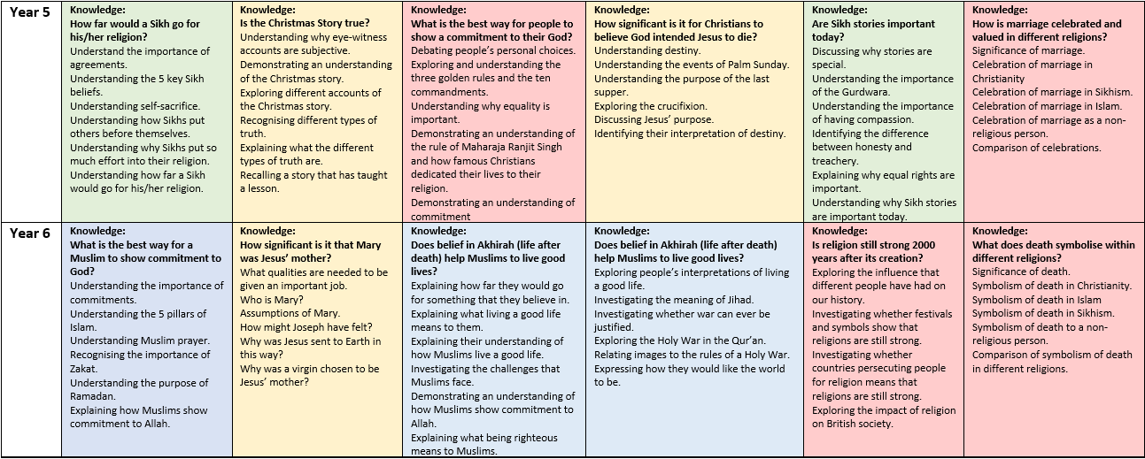

Appendix 2
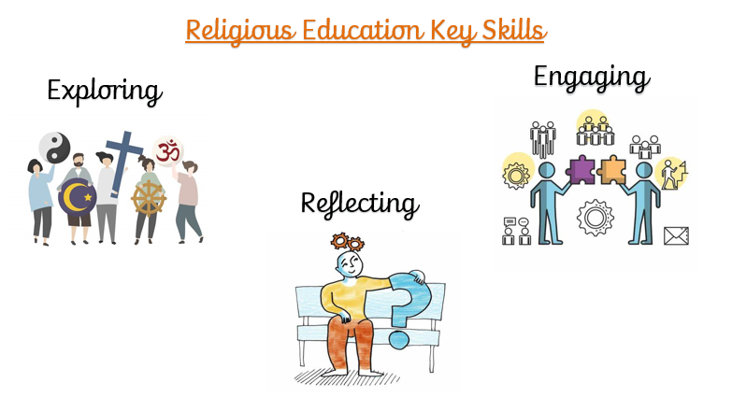

Appendix 3
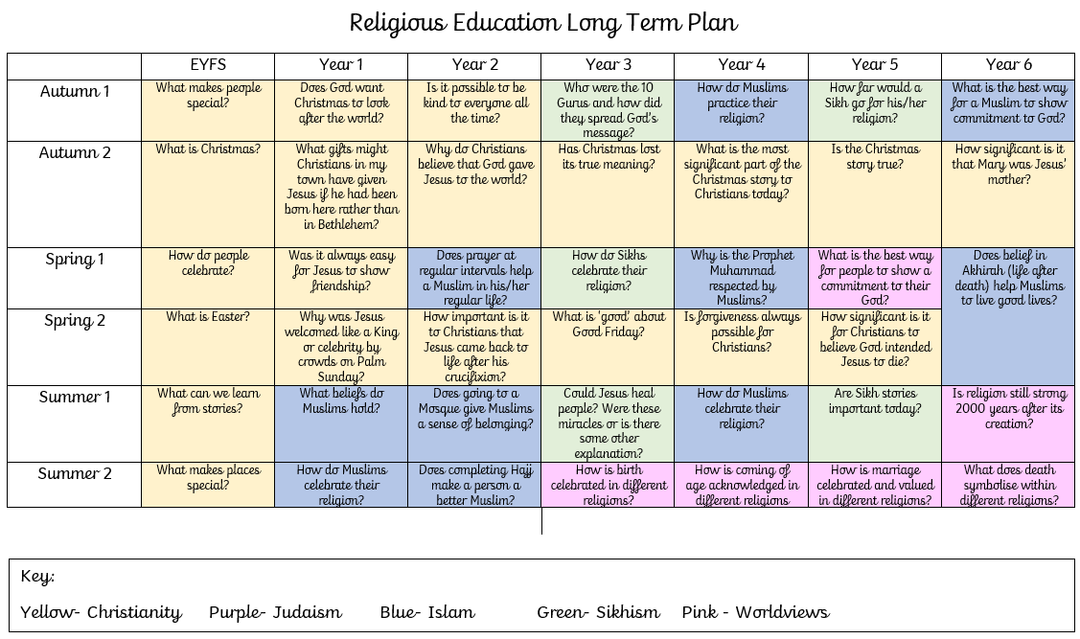

Appendix 4

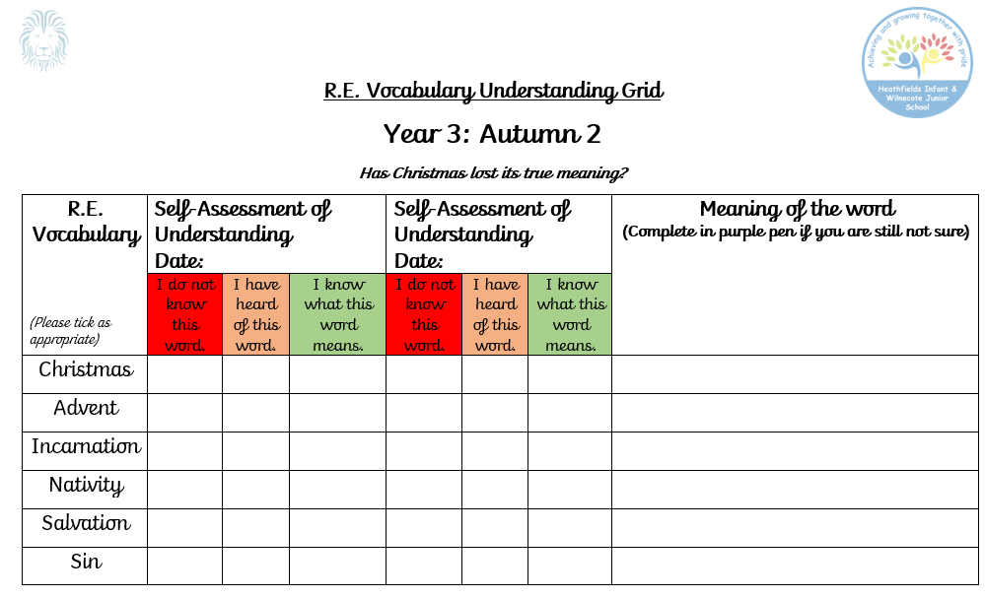
Appendix 5

