Fierte Multi-Academy Calculation Policy – addition
Key language: sum, total, parts and wholes, plus, add, altogether, more, ‘is equal to’, ‘is the same as’
Concrete | Pictorial | Abstract
Combining two parts to make a whole (use other resources too e.g. eggs, shells, teddy bears, cars).  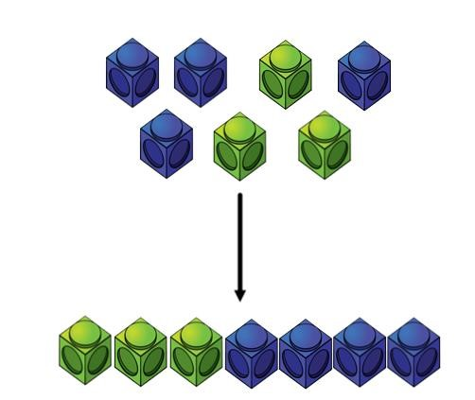 | Children to represent the cubes using dots or crosses. They could put each part on a part whole model too.  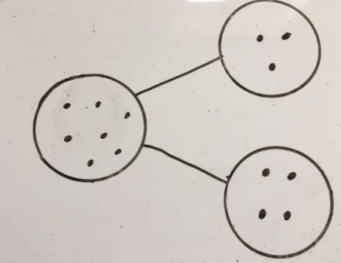 | 4 + 3 = 7  Four is a part, 3 is a part and the whole is seven.  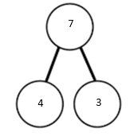  Use the part, part whole diagram to move into the abstract.
Counting on using number lines using cubes or Numicon.  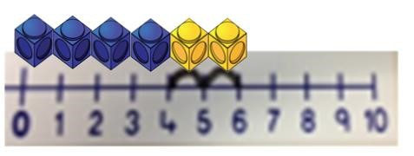  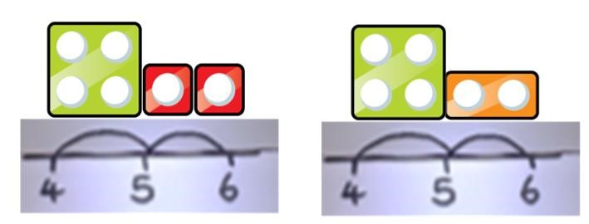  Starting at the bigger number and counting on | A bar model which encourages the children to count on, rather than count all.  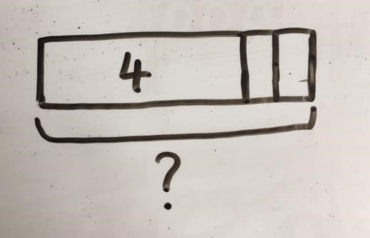 | The abstract number line:  What is 2 more than 4?  What is the sum of 2 and 4?  What is the total of 4 and 2?  4 + 2  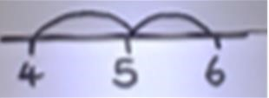

Regrouping to make 10; using ten frames and counters/cubes or using Numicon.  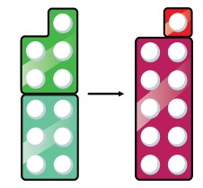  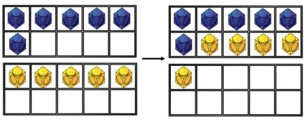  6 + 5 = 11  Start with the bigger number and use the smaller number and use the smaller number to make 10.  Adding Three Single Digits: |  | Children to draw the ten frame and counters/cubes.  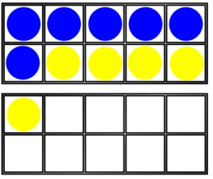  Add together three groups of objects. Draw a picture to recombine the groups to make 10. |  | Children to develop an understanding of equality e.g.  6 + □ = 11  6 + 5 = 5 + □  6 + 5 = □ + 4  Combine the two numbers that make 10 and then add on the remainder.
TO + O using base 10. Continue to develop understanding of partitioning and place value.  41 + 8  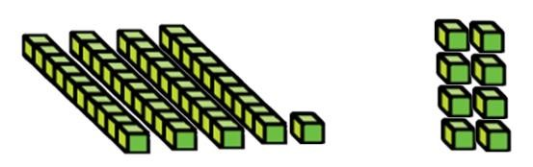  Column method – no regrouping |  | 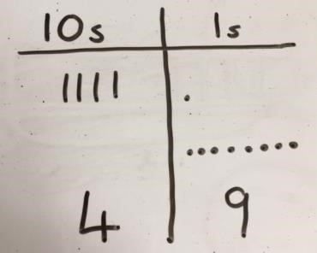  Children to represent the base 10 e.g. lines for tens and dot/crosses for ones.  After practically using the base 10 blocks and place value counters, children can draw the counters to help them to solve additions. |  | 41 + 8  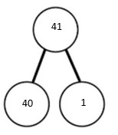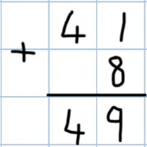  1  + 8 = 9  40  + 9 =  49
Column method –regrouping  TO + TO using base 10. Continue to develop understanding of partitioning and place value.  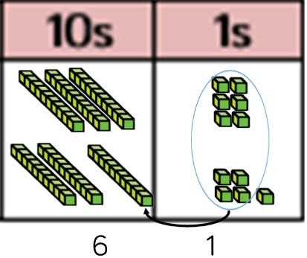  36 + 25 |  | Chidlren to represent the base 10 in a place value chart.  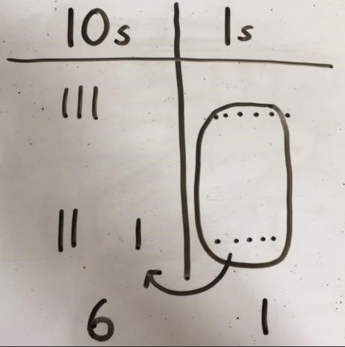 |  | Looking for ways to make 10.  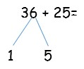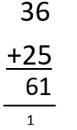  30  + 20 =  50  5  + 5 =  10  50  + 10 + 1 =  61  Formal method:  Start by partitioning the numbers before moving on to clearly show the exchange below the addition.  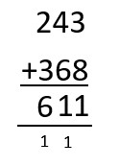
Use of place value counters to add HTO + TO, HTO + HTO etc. When there are 10 ones in the 1s column- we exchange for 1 ten, when there are 10 tens in the 10s column- we exchange for 1 hundred.  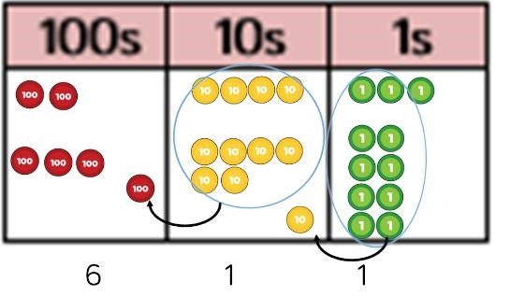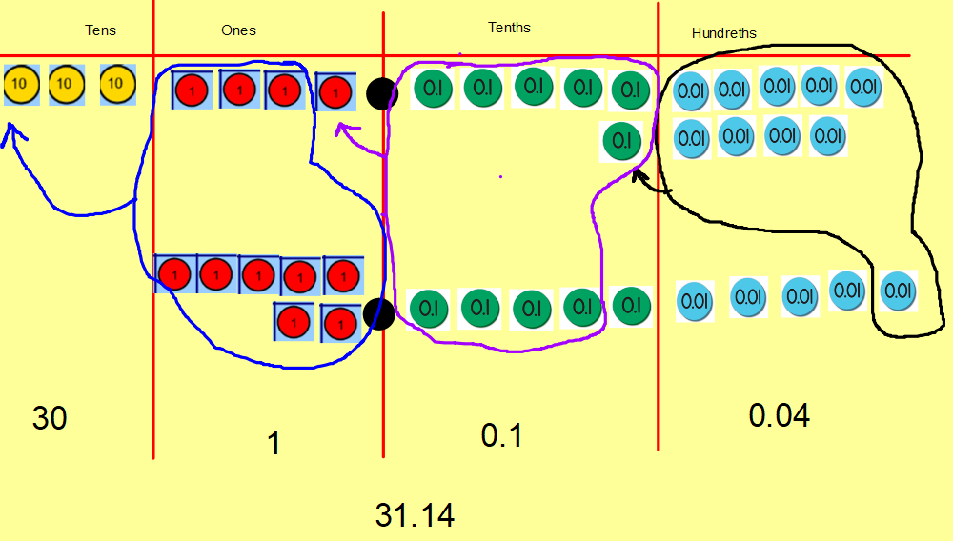 |  | Children to represent the counters in a place value chart, circling when they make an exchange.  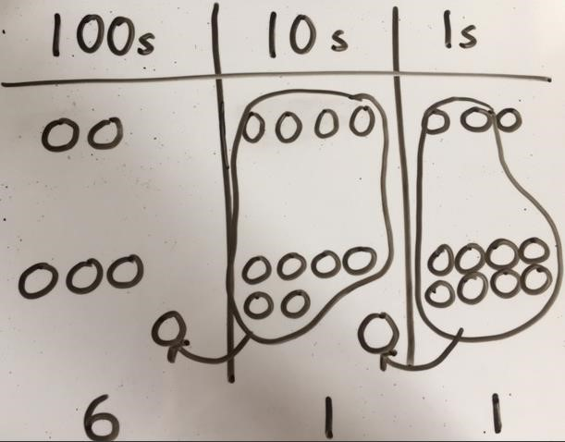  Children can draw a pictorial representation of the columns and place value counters to further support their learning and understanding. |  | As the children move on, introduce decimals with the same number of decimal places and different. Money can be used here.
Conceptual variation; different ways to ask children to solve 21 + 34
 | Word problems:
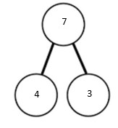  21  34  ?  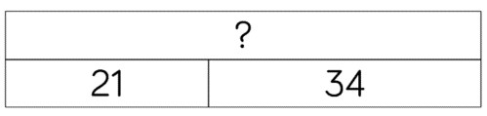 | In year 3, there are 21 children and in year 4, there are 34 children.  How many children in total?  21 + 34 = 55. Prove it |  | 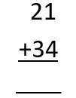  21 + 34 =  = 21 + 34  Calculate the sum of twenty-one and thirty-four. | 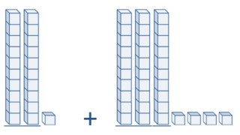  Missing digit problems:  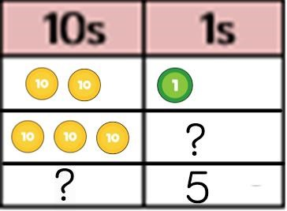

, subtract, minus, fewer, decrease.

